Special Education Needs Policy
Purpose
The purpose of this policy is to give guidance on how BELS faculty members provide educational support to all students. This policy explains not only plans to support students with special needs, but for how BELS provides differentiation, remediation, and extension to students when needed in order for students to be successful in national and international programs.

In this policy you can find:
- Definition of terms
- Reference to Program Policies
- Role of the Counselor
- Role of the Teacher
  - Differentiation strategies
  - Remediation Procedures
- Confidentiality Policy
- Language Support
- Supporting the gifted and talented students
- Whole School Approach to Individualized Counseling
- Applications for inclusive assessment arrangements
  - Referral Form
- Professional Development of teachers
- Supporting Documentation

Definition of terms
- Special needs- “Education designed to facilitate the learning of individuals who, for a wide variety of reasons, require additional support and adaptive pedagogical methods in order to participate and meet learning objectives in an educational programme” (Unesco, 2011).
- Differentiation- Differentiation refers to a wide variety of teaching techniques and lesson adaptations that educators use to instruct a diverse group of students, with diverse learning needs, in the same course, classroom, or learning environment. (Education Glossary)
- Remediation- the reteaching of material, generally to a small group of students using different methods of instruction then in the whole class.
- Gifted and Talented- Students with gifts and talents perform - or have the capability to perform - at higher levels compared to others of the same age, experience, and environment in one or more domains. They require modification(s) to their educational experience(s) to learn and realize their potential. (National Association of Gifted Children)
- Accommodations- particular access arrangements provided by the school to meet the needs of students
- Personal improvement plan- a school-based individually created plan by the counselors in collaboration with the teachers and parents to support a student’s learning.

Reference to Program Policies
- International Baccalaureate Policy
- International General Certificate of Secondary Education (IGCSE) Policy
- MEB (Ministry of Education) Policy

Role of the Counselor
School counselors provide direct and indirect services to students in the least restrictive environment (as determined by each student’s individualized education plan [IEP]) and in inclusive settings when possible (Tarver-Behring, Spagna & Sullivan, 1998).
School counselor responsibilities include:
- Understanding the student's problem and providing the necessary guidance
- Conducting the referral process
- Being part of the natural member of Individualized education program (IEP) development unit
- Providing individual and/or group counseling to students with special needs within the scope of the school counseling program
- Providing short-term, goal-focused counseling in instances where it is appropriate to include these strategies as a part of the IEP
- Encouraging family involvement in the educational process
- Consulting and collaborating with staff and families to understand the special needs of a student and understanding the adaptations and modifications needed to assist the student
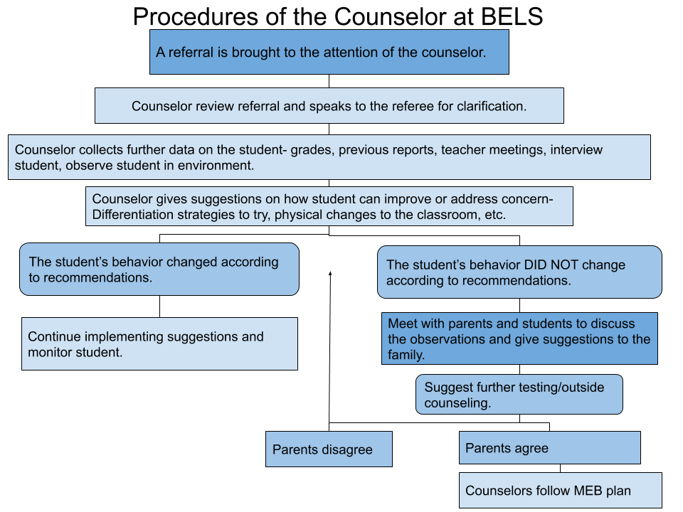

Confidentiality
Every student’s right to be treated with respect and dignity (ASCA, 2016). It is the school counselors’ responsibility to fully respect the right to privacy of those with whom they enter a counseling relationship and to provide an atmosphere of trust and confidence (Lazovsky, 2008). Confidentiality is also the basis for an effective counseling relationship. Confidentiality ensures that school counselors won’t share students’ disclosures with others except when the student authorizes it or when there is a clear and present danger to the student and/or to other persons.
As counseling with a student progresses, it may become beneficial or necessary for the school counselor to consult and collaborate with parents. Either the parent or the professional school counselor may initiate the collaboration process. It’s the school counselor’s responsibility to reach an agreement with the student about what information to share with the parents. Unless, of course, there is a clear and imminent danger to the student or others.
The limitations of confidentiality don’t include information of possible abuse or harm to a child. By law, school counselors must report any case of abuse or neglect to the appropriate authorities. School counselors inform parents/guardians or appropriate authorities when a student’s condition indicates a clear and imminent danger to the student or others. This is done after careful deliberation and, where possible, after consulting with other counseling professionals. The school counselor will attempt to minimize the threat to a student and may choose to inform the student of actions to be taken or involve the student in a three-way communication with parents/guardians when breaching confidentiality or allow the student to have input as to how and to whom the breach will be made.

Student Support
Support is provided to students who are having academic difficulties or who have been identified through a referral process as needing supplementary instruction in order to successfully develop to their fullest potential. This consists initially of the teachers, supported by the school counsellors and program coordinators, providing remedial skills instruction.

In order to support the gifted students, BELS creates a new special needs committee specific to the student and define the student’s needs, discuss alternative ways of supporting the student in alignment with the national and international curriculum, and put them in action after receiving the Enriched Educational Plan from the counselor. The student may be supported by being supervised for a research/project, etc., guided by the school to participate in national and international seminars, conferences, workshops, and other related events that the student can identify, reflect, and further develop his/her potential.

The Role of the Teacher
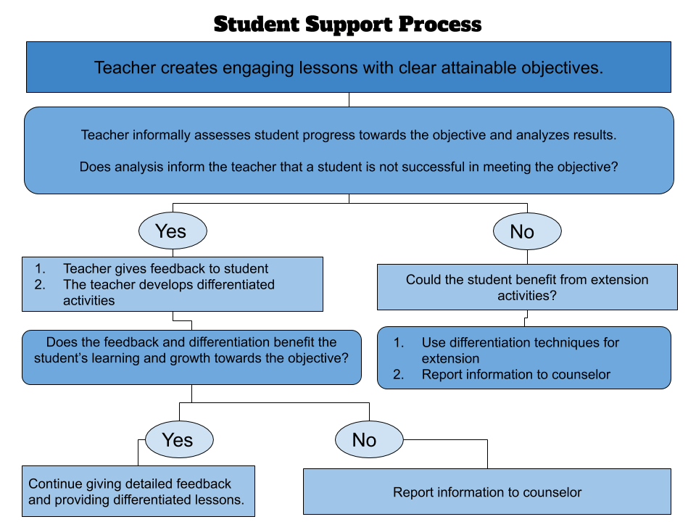

Teachers are responsible for continuous informal and formal assessments of student learning to ensure that each student has engaged in the learning process and can prove that learning has occurred. These assessments aid teachers in making informed decisions about their educational plans for the students. Teachers have the flexibility to reteach and reassess students or even provide extension activities if their assessments show the need.
When teachers find a student struggling with content materials, they begin to investigate the reason behind the difficulty. Teachers can do this through interview, further assessment, or analysis of student work. Teachers can turn to counselors or curriculum specialists for guidance on these matters.
Teachers then should make differentiation plans to support the student in the classroom. A list of potential differentiation strategies can be found linked to the end of this document. If differentiation strategies are not showing a positive effect on the student’s performance, then the student can be referred to after school remediation courses. The teacher should also inform the counselor about the struggles the student is facing.
For students with learning difficulties, or those who require additional language support, direct remedial instruction is offered. These remedial classes are offered during the regular school day, after school or Saturdays. These may be taught by either the classroom teacher or a different subject specialist from that department. The remedial is offered to students who attend lessons regularly and fulfills his/her responsibilities.
For all students, teachers develop lessons that are engaging and differentiated to meet the needs of students.
Gifted students are supported through the development of breadth and depth of their classroom curriculum and additional activities such as independent projects, providing evidence of learning in a different way, participating in national and international seminars and conferences, or additional projects based on the student’s interest.

Language / Academic Support Programs
For English, language support is available in the school. Students are either referred by the teachers (see student referral form) or are selected based on whole school testing. The counsellors in consultation with the program coordinators, teachers and parents, develop an action plan which is best suited for the students’ needs. This is generally done through remedial classes (available for all international program subjects) or in-class support. At all levels the program aims to provide continuity of instruction and develop communicative competence.
For Turkish, language support is provided by the Turkish teachers on a needs basis.
Gifted and Talented Students
The gifted and talented child may develop much earlier than their peers in some areas, learn much faster than other children of their age, and show excessive interest in areas of interest, unlike other students. Gifted and talented children can have all of these features, as well as only some of them. Despite these differences, it can be difficult to recognize and diagnose gifted children. Moreover, early recognition of giftedness in children and creating suitable educational environment is extremely important, but also difficult, especially for educators (Winebrenner, 1992). Therefore, it is necessary to follow the children very well in the classroom and try to understand the differences in their daily speech (Smutny, Walker & Meckstroth, 1997). At BELS, the guidance and psychological counseling (GPC) service carries out the support and referral processes. GPC service is in close contact with homeroom teachers and gathering all the differences and observations to overcome this difficulty. In addition to that, this unit also combines other teachers’ observations and their observations by conducting individual interviews and applying individual recognition techniques, for example, personality, interest and value inventories. If the student is deemed to be gifted as a result of the observations due to the fact that no diagnosis is made in the school in accordance with the Ministry of Education (MEB) rules and regulations, the student is referred to the Yakutiye Guidance and Research Center (RAM) unit with the help of a psychological counselor. When this unit diagnoses the student as gifted, it notifies the school with an official letter. In addition to this, the students who were discovered as gifted in their previous school or independently from the school, the relevant RAM that discovered this again notifies the school with an official letter. After this official letter, the Enriched Education Program (EEP) committee is created in the light of the recommendations of the RAM. The EEP committee includes the vice principal, psychological counselor, the student's family and all teachers who attend student’s classes by the guidance of the school principal. The committee chair is assigned the principal. Support can be obtained from Yakutiye RAM in creating the committee and in the decisions to be taken. If required, this committee can make changes in the student's course schedule, course contents, course hours, homework, materials to be used, etc. One of the purposes of having parents at the meeting is to ensure cooperation and to inform the parents about the process. Decisions are taken unanimously, and the student's progress is closely monitored by the teachers and psychological counselor.

Whole School Approach to Individual Counselling
In order to nurture the self actualization of students, school counselors, teachers, and parents work in collaboration and take necessary actions when needed.

Counselling / Academic Coordinator Services include:
• Behavior management support
• Individual personal counselling
• Group counselling
• Social skills training
• Parent consultations
• Staff in-service training
Applications for Inclusive Assessment Arrangements
- All requests for inclusive assessment arrangements must be made by parents in writing to the school administration. Parents are responsible for providing all the required documentation.
- All requests for inclusive assessment arrangements will be submitted prior to the deadline as determined for the international examinations. Approval of inclusive assessment arrangement requests are made by the international organization, not the school.
- All requests for accommodations within the school are determined by the school administration.

Supporting Documentation
List of special education needs that may be present at BELS
Referral Form

Professional Development

BELS faculty is going to be trained on a regular basis in order to implement differentiation strategies for these students in and out of the classroom. These trainings may differ for each year or each division in terms of the need specifically.

Policy Review Cycle:
The Special Needs Policy is reviewed at the start of each odd numbered academic year by the counseling department and shared with the faculty for input. Final approval is made by the BLT.
Reviewed and Approved by the BLT 12.11.2020

